Mullingar Greenway Recreation Hub at Grange South - Project Particulars

- Overview

  - Introduction
This project aims to expand the recreational facilities available along Westmeath’s Greenways, at a strategic and pivotal position in proximity of the Royal Canal Greenway and the the Old Rail Trail Greenway, as part of the Dublin to Galway Project. The Dublin to Galway Cycleway aims to be the first Coast to Coast Greenway and will be a recreational tourism product of international scale and standard, forming part of the Eurovelo 2 route from Galway to Moscow. To date, approximately 14 million has been invested in Westmeath’s Greenways and the Council are working with communities to create the necessary linkages, facilities and amenities required to enable these Greenways to reach their full potential.
This project also aims to provide better accessibility to these local amenities for the residents in this area of Mullingar who although are living adjacent to these significant recreation assets, have been unable to easily access them.
  - Location
The location of this project is at within close proximity of two significant cross-country Greenways, the Royal Canal Greenway and the Old Rail Trail Greenway.
The entire site measures approximately 1.6km in length running along the Northern bank of the Royal Canal from the Newbrook bridge on the Westernmost end to the Green bridge the NorthEasternmost end.
The overall area of the site is approximately 3.3 Hectares.
The proposed Recreational Hub will occupy the Western end of the linear Park centred within a Green Space area of approximately 2.0 hectares.
This proposed recreational hub at Grange South is a large-scale recreation infrastructure development which will encompass the existing Newbrook Amenity Area, creating a much needed facility for outdoor recreation at a strategic juncture where national scale greenways meet.

- Project Elements and Description

  - Greenway Track
The proposed new track will run along the North bank of the Royal Canal for approximately 1.6km.
The new track will link in with the existing Greenway track at the Newbrook Bridge Amenity area on the Western end and will provide a direct link onto the Clonmore road (L-2201-1) via pedestrian bridge on the North-Easternmost end.
The track will be 3 metres in width and consist of a bound surface suitable for cyclists, pedestrians, buggies and wheel chair users. Access to the track will be provided at a number of locations within the park as indicated on the site layout plan.

  - Footpaths
Footway links within the park will be provided as per the site layout drawing. The surface finish will be a bound surface of varying widths and grades suitable for pedestrians, buggies and wheel chair users.

  - Pedestrian Bridge
It is proposed to locate a pedestrian bridge over the Royal Canal offset from the Green bridge in line with the existing pedestrian crossing on the Clonmore Road.
The proposed bridge location will facilitate a graded approach to the bridge along the Northern Bank of the Royal Canal negating the requirement for steps on approach. Access from the bridge onto the Clonmore Road will be at grade.
Proposed bridge position and details as shown on the site Layout drawings are indicative and are subject to more detailed design as the project progresses.

The possible future removal of the existing pedestrian bridge over the Royal Canal at Martketpoint is also proposed.
.
  - Pedestrian crossings
Two no. signal controlled pedestrian crossings are proposed along the R392 Grange South road adjacent the Newbrook Carpark and adjacent to Woodlands Avenue as indicated on the site layout drawing.
The crossings will serve to provide safe access points to the existing Newbrook amenity area and access to the proposed recreation hub along pedestrian desire lines from the residential areas to the Northern side of the R392. Both crossings will also serve as an effective speed control measure along the R392.
A third uncontrolled pedestrian crossing is proposed on the R392 in line with the footpath adjacent to the junior Bike trails as indicated on the site layout drawing.

  - Junior Bike park/Pump Track and Activity wall
The location of the proposed Junior bike park and Activity wall are shown on the site layout drawing. Images shown on the layout drawing and below are indicative only and the future detailed design and construction will be by specialist Contractor.

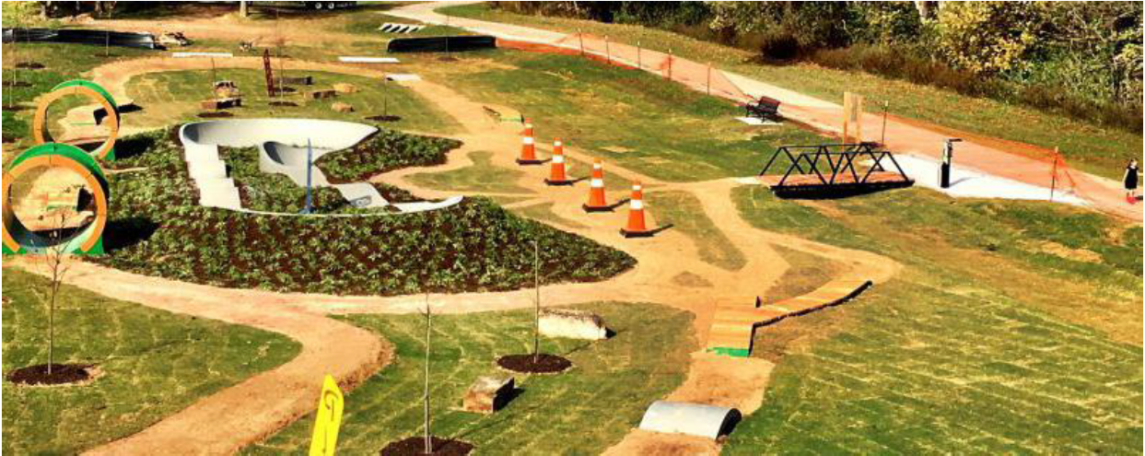

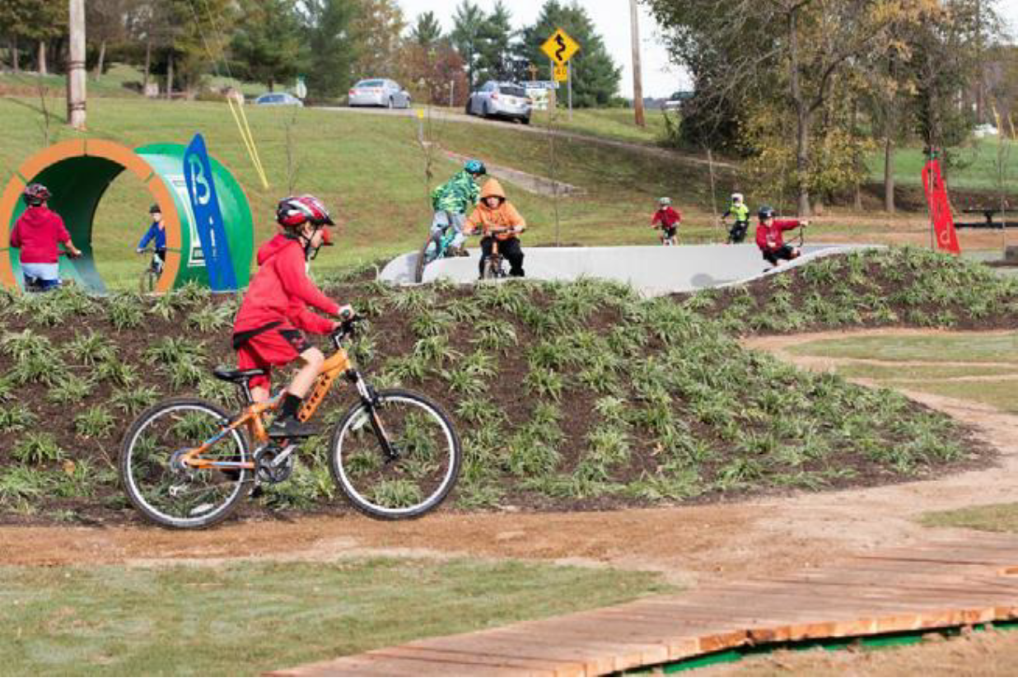

  - Playground at Newbrook Amenity Park
A future playground is proposed adjacent to the existing Newbrook amenity area but this is not included in the funding for the Greenway Recreation Hub at Grange South.

  - Landscaping and planting
In general all the existing trees will be preserved. Green spaces are to be preserved and maintained as grassed areas and reseeded as necessary.
In addition it is proposed to introduce new Native Tree, Hedge & pollinator friendly perennial planting as indicated on the layout drawing. Final positions, quantities and species to be confirmed prior to construction stage. See Appendix A proposed list of Native tree Species.

  - Public Lighting
It is proposed to provide public lighting along the new Greenway track and along the footways within the Recreation Hub.
Positions of lights as shown on the site layout drawing are indicative only and the final lighting design to include specification on fixtures and fittings will be prepared by a qualified lighting designer to include LED fittings throughout.

Appendix A
Schedule of proposed Native trees for planting.

- Ash Fuinseog (Fraxinus excelsior)
- Silver Birch Beith gheal (Betula pendula)
- Wild Cherry Gean – crann silíní fiáin (Prunus avium)
- Crab Apple Crann fia-úll (Malus sylvestris)
- Hazel Coll (Corylus avellana)
- Willow Saileach (Salix spp.)

Note: Selected trees for planting will be of Girth 8-10cm and height 2.5-3m.

