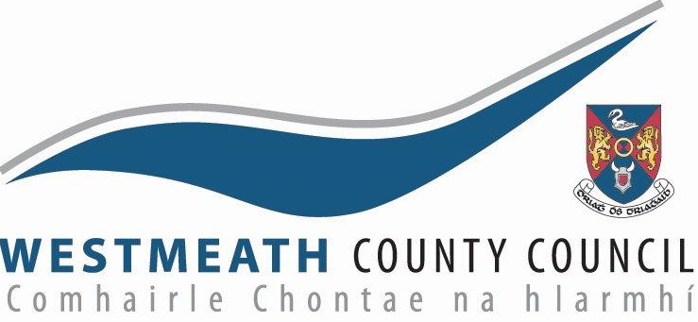

PLANNING AND DEVELOPMENT ACT 2000 (as amended) (Part XI)
PLANNING AND DEVELOPMENT REGULATIONS, 2001 (as amended) (Part 8)

SITE NOTICE

Notice is hereby given in accordance with the requirements of the above Regulations that Westmeath County Council proposes to undertake the following works:

Creation of a Community Space in Fore
The works will involve:-

- Creation of a high-quality paved community space
- Completion of missing section of heritage stone wall
- Road surfacing and road markings
- Public lighting.

The proposed scheme has undergone Appropriate Assessment Screening under the Habitats Directive (92/43/EEC) and screening for Environmental Impact Assessment under the EIA Directive 2014/52/EU. Any person may, within 4 weeks from the date of this notice, apply to An Bord Pleanála for a screening determination as to whether the proposed development would be likely to have a significant effect on the environment.

Plans and Particulars of the proposed development are available for inspection at https://consult.westmeathcoco.ie/en and can be inspected or purchased at a fee not exceeding the reasonable cost of making a copy at the offices of Westmeath County Council, Áras an Chontae, Mount Street, Mullingar, N91 FH4N from 9.30 a.m. to 4.00 p.m. each day, excluding weekends and Bank Holidays, from 24th July, 2023 up to and including Monday 21st August, 2023.

Submissions and observations with respect to the proposed development, may be made in writing no later than 4pm on Monday 4th September, 2023 either:
• Online at https://consult.westmeathcoco.ie/en or
• In writing, clearly marked “Part 8, Creation of a Community Space in Fore” to the Administrative Officer, Planning Section, Westmeath County Council, Áras An Chontae, Mount Street, Mullingar, N91 FH4N.

Written submissions or observations received, will form part of a statutory report to be presented to a meeting of Westmeath County Council and will form part of a public document. The information contained in submissions may be available for public inspection, to be published on the Council’s website and available at the Council’s public counter. Details, including the names of those making submissions may be shared with relevant Council Departments or their agents involved in this Part 8 process.

Signed S. Healy Date 22nd July, 2023
District Manager

