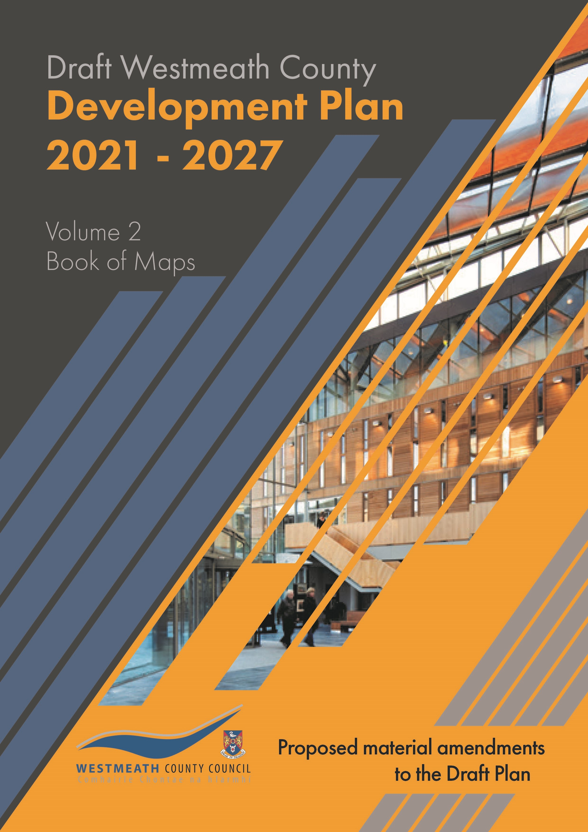
Contents

Proposed Amendment | Map Title | Page no.
1 | Castlepollard Zoning | 2
2 | Castlepollard Zoning | 3
3 | Castlepollard Zoning | 4
4 | Castlepollard Objective | 5
5 | Kilbeggan Zoning | 6
6 | Kilbeggan Zoning | 7
7 | Kilbeggan Objective | 8
8 | Kinnegad Zoning | 9
9 | Kinnegad Zoning | 9
10 | Kinnegad Zoning | 9
11 | Moate Zoning | 11
12 | Moate Objective | 12
13 | Killucan Rathwire Zoning | 13
14 | Killucan Rathwire Zoning | 14
15 | Killucan Rathwire Objective | 15
16 | Rochfortbridge Zoning | 16
17 | Rochfortbridge Zoning | 17
18 | Clonmellon Objective | 18
19 | Delvin Zoning | 19
20 | Delvin Objective | 20
21 | Tyrrellspass Zoning | 21
22 | Ballinalack Objective | 22
23 | Ballymore Zoning | 23
24 | Ballymore Objective | 24
25 | Castletown Geoghegan Zoning | 25
26 | Castletown Geoghegan Zoning | 26
27 | Castletown Geoghegan Objective | 27
28 | Collinstown Objective | 28
29 | Glasson Zoning | 29
30 | Glasson Zoning | 30
31 | Milltownpass Zoning | 31
32 | Multyfarnham Zoning | 32
33 | Loughnavalley Node | 33
38 | High Amenity Area | 34
37 | High Amenity Area | 35
36 | Wind Energy Capacity | 36

Proposed Amendment BOM 1

Title | Map No.
Castlepollard Zoning | 2

Change zoning from unzoned to “Proposed Residential”

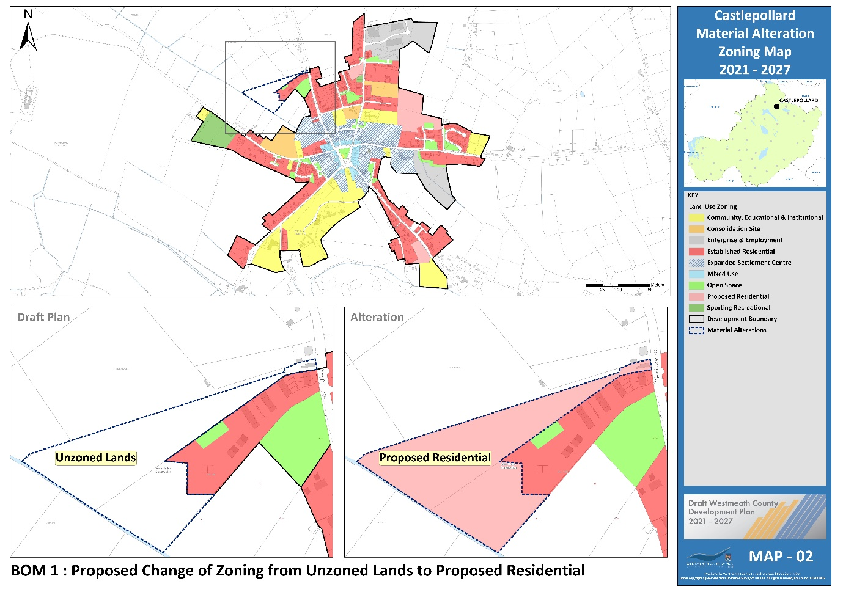

Proposed Amendment BOM 2

Title | Map No.
Castlepollard Zoning | 2

Change zoning from unzoned to “Consolidation Site”

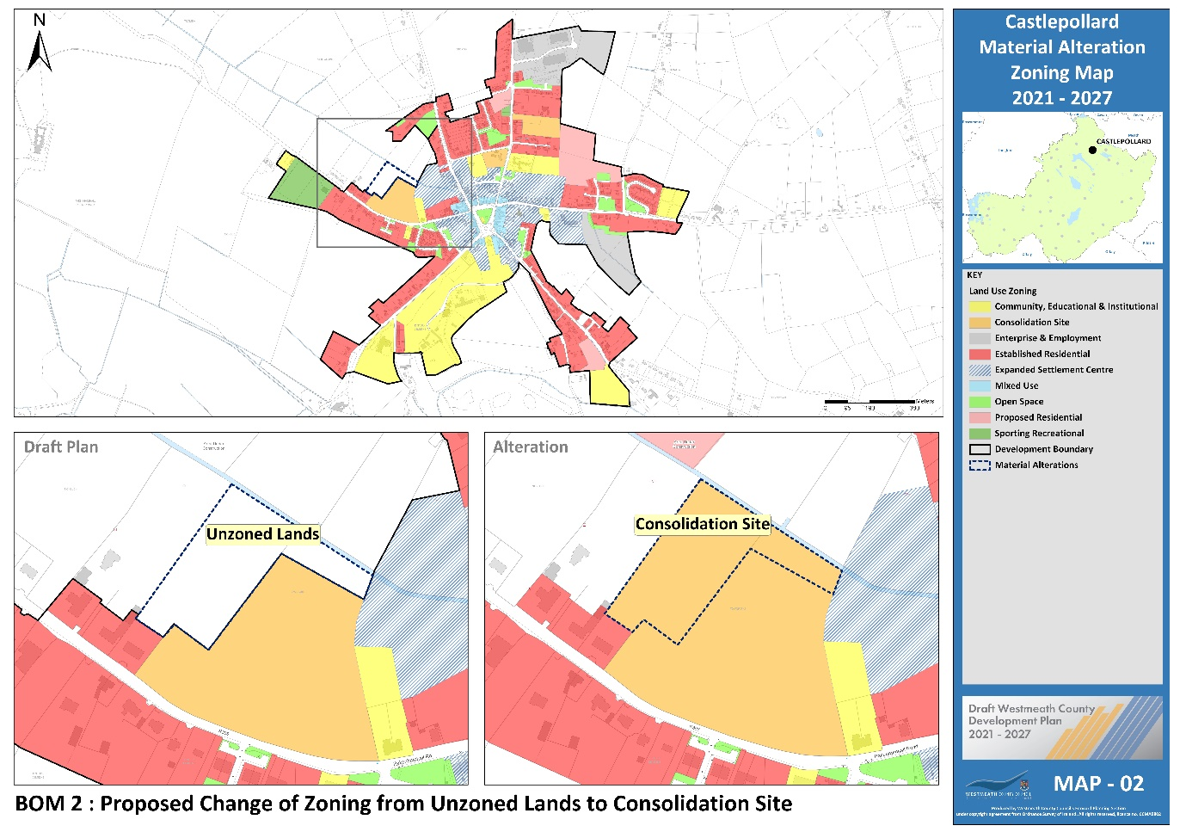

Proposed Amendment BOM 3

Title | Map No.
Castlepollard Zoning | 2

Change zoning from unzoned to “Proposed residential”

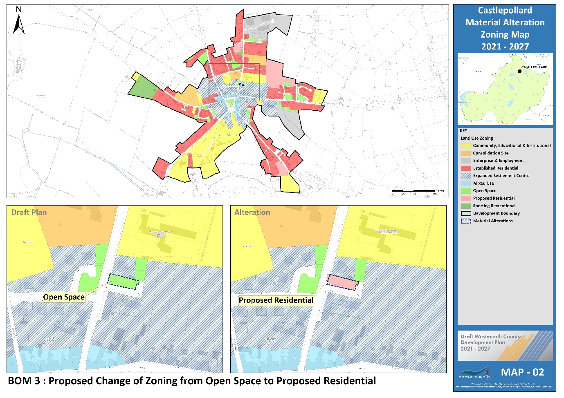

Proposed Amendment BOM 4

Title | Map No.
Castlepollard Objective | 3

Insert new CPO for Castlepollard under section 8.3.1.6 of the plan as follows:
Development proposals on identified lands shall be accompanied by a site-specific Flood Risk Assessment (FRA) carried out in accordance with the methodology set out in ‘The Planning System and Flood Risk Management – Guidelines for Planning Authorities, 2009’ (See Map 3 MBLO CP 1-4).
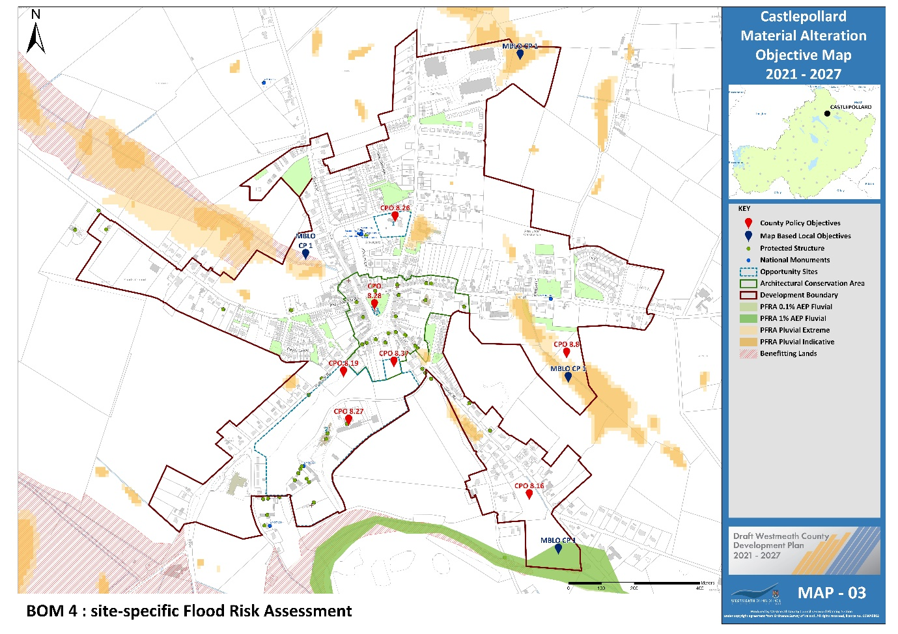

Proposed Amendment BOM 5

Title | Map No.
Kilbeggan Zoning | 4
Change zoning from “Open Space” to “Proposed Residential”.

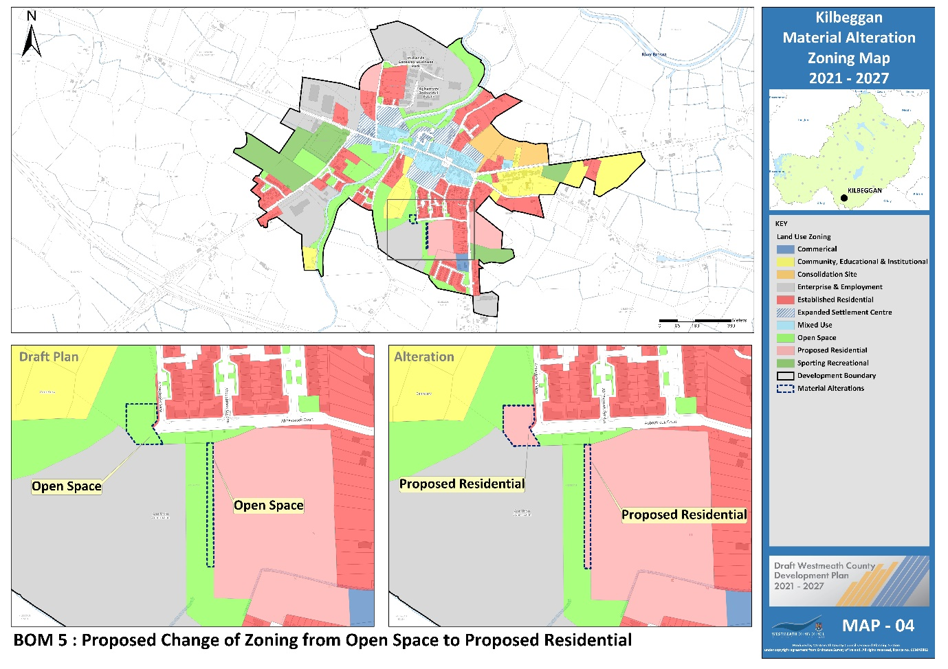

Proposed Amendment BOM 6

Title | Map No.
Kilbeggan Zoning | 4

Change zoning from “Open Space” to “Sporting Recreational”

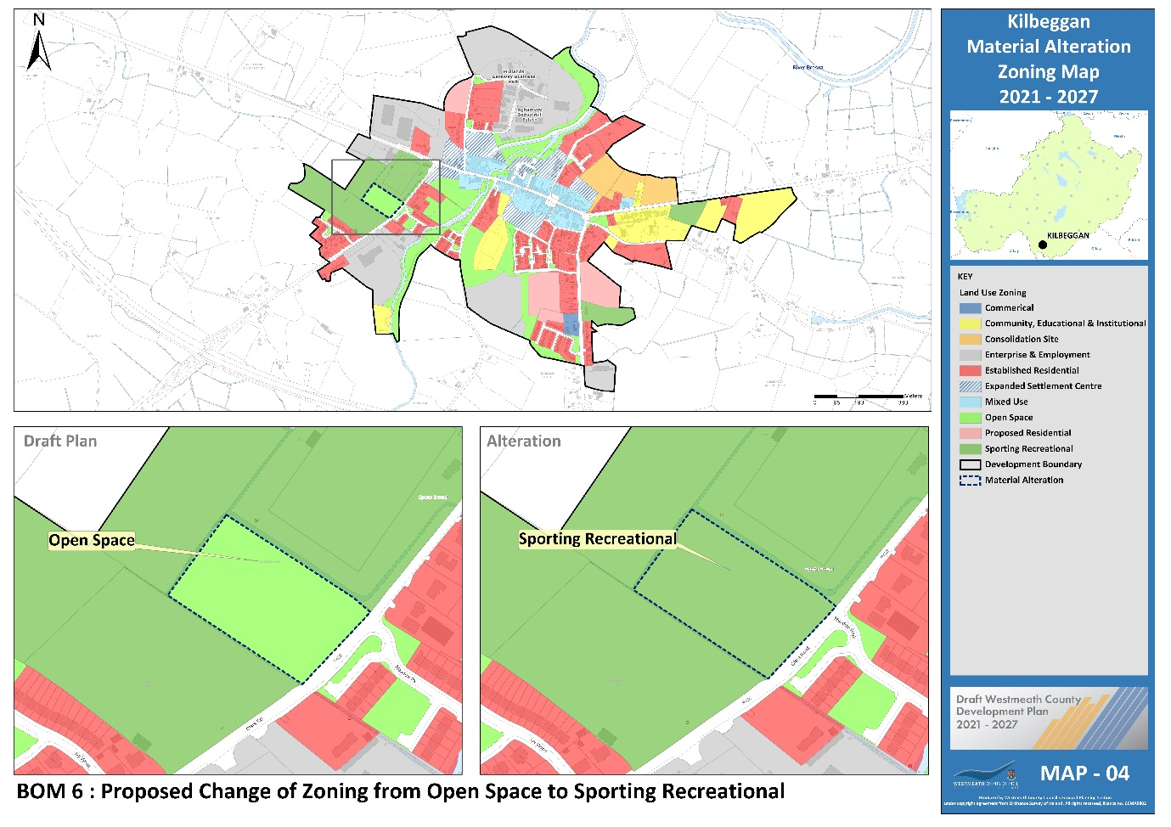

Proposed Amendment BOM 7

Title | Map No.
Kilbeggan Objective | 5

Insert new CPO for Kilbeggan under section 8.3.2.6 of the plan as follows:
Development proposals on identified lands shall be accompanied by a site-specific Flood Risk Assessment (FRA) carried out in accordance with the methodology set out in ‘The Planning System and Flood Risk Management – Guidelines for Planning Authorities, 2009’ (See Map 5 MBLO KB 1).

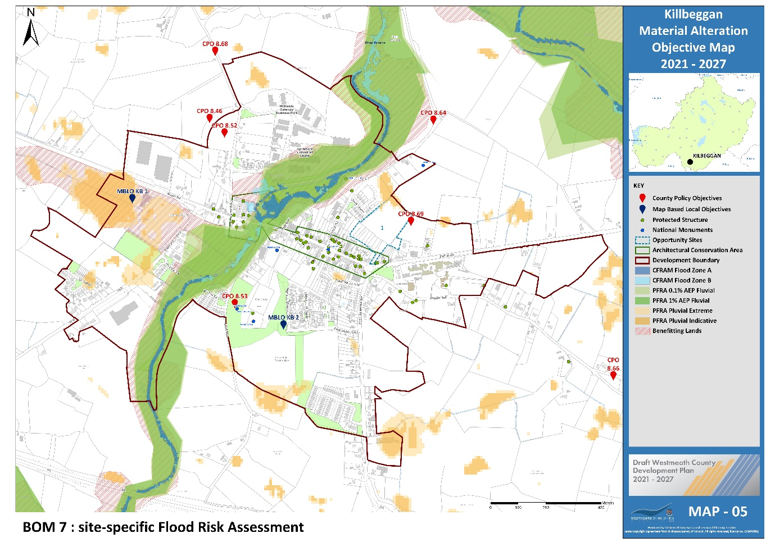

Proposed Amendment BOM 8

Title | Map No.
Kinnegad Objective | 7
Insert new map-based objective after CPO
To allow the appropriate consideration of provision of a nursing home with an activity facility and meeting room as a central area for a small cluster of housing that would support an elderly population in accessing services they require locally in a sustainable development (See Map 7 MBLO KG 2).

Proposed Amendment BOM 9

Title | Map No.
Kinnegad Objective | 7
Insert new CPO after CPO 8.97 as follows;
To support the development of an indoor sports centre and meeting rooms at Coralstown Kinnegad GAA in conjunction with all the voluntary and sporting groups in the area (See Map 7 MBLO KG 1).

Proposed Amendment BOM 10

Title | Map No.
Kinnegad Objective | 7
Insert new CPO for Kinnegad under section 8.3.3.7 of the plan as follows:
Development proposals on identified lands shall be accompanied by a site-specific Flood Risk Assessment (FRA) carried out in accordance with the methodology set out in ‘The Planning System and Flood Risk Management – Guidelines for Planning Authorities, 2009’ (See Map 7 MBLO KG 3).
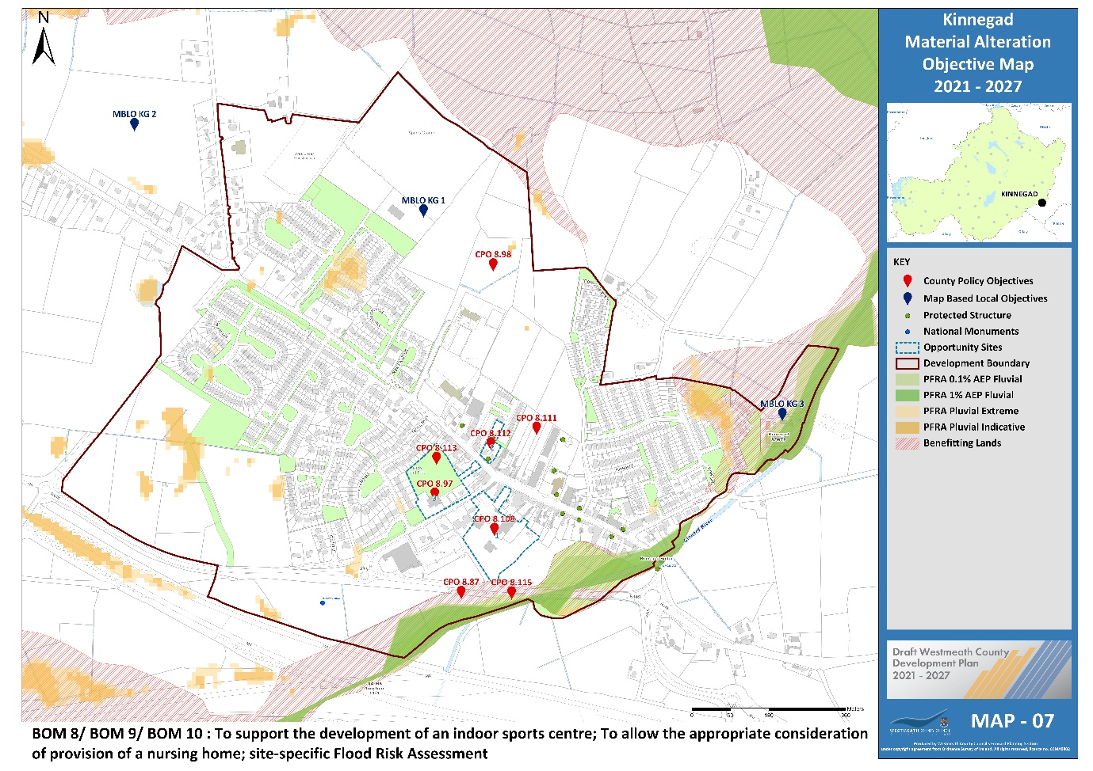

Proposed Amendment BOM 11

Title | Map No.
Moate Zoning | 8

Change zoning from “Open Space” to “Proposed residential”

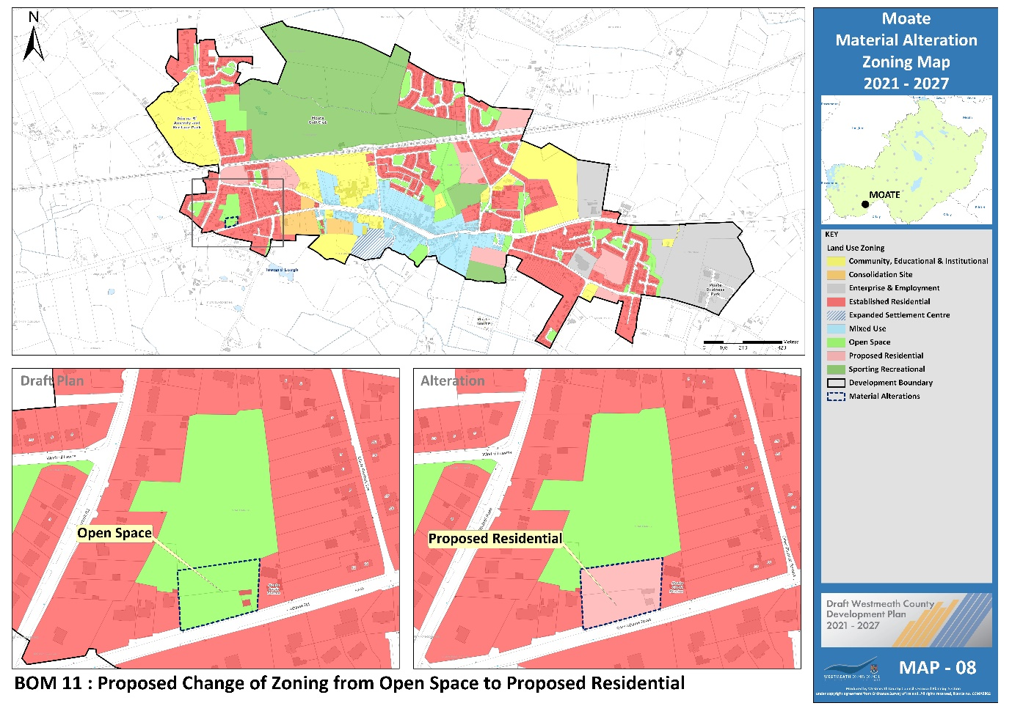

Proposed Amendment BOM 12

Title | Map No.
Moate Objective | 9
Insert new CPO for Moate under section 8.3.4.6 of the plan as follows:
Development proposals on identified lands shall be accompanied by a site-specific Flood Risk Assessment (FRA) carried out in accordance with the methodology set out in ‘The Planning System and Flood Risk Management – Guidelines for Planning Authorities, 2009’ (See Map 9 MBLO ME 1).

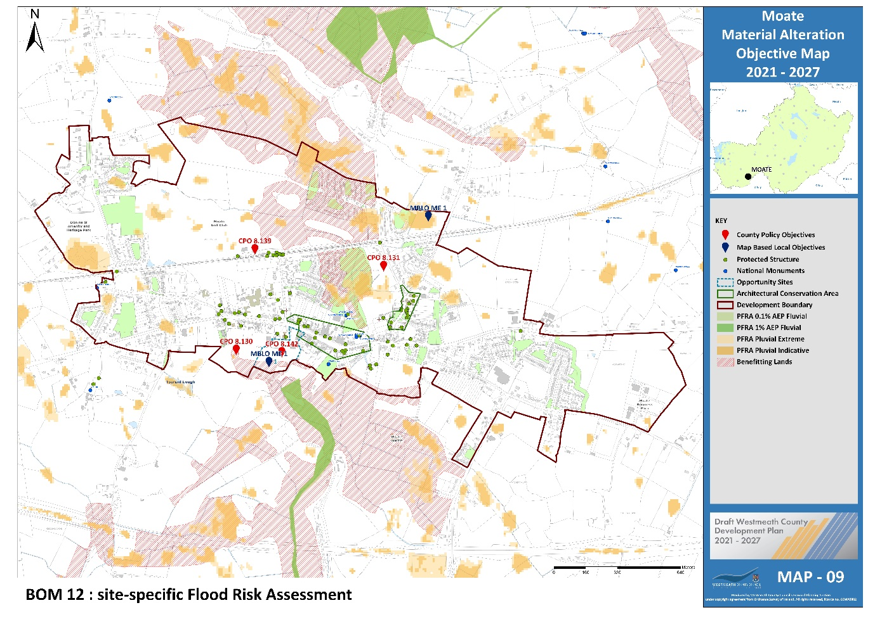

Proposed Amendment BOM 13

Title | Map No.
Killucan Rathwire Zoning | 10

Change zoning from unzoned to “Proposed residential”

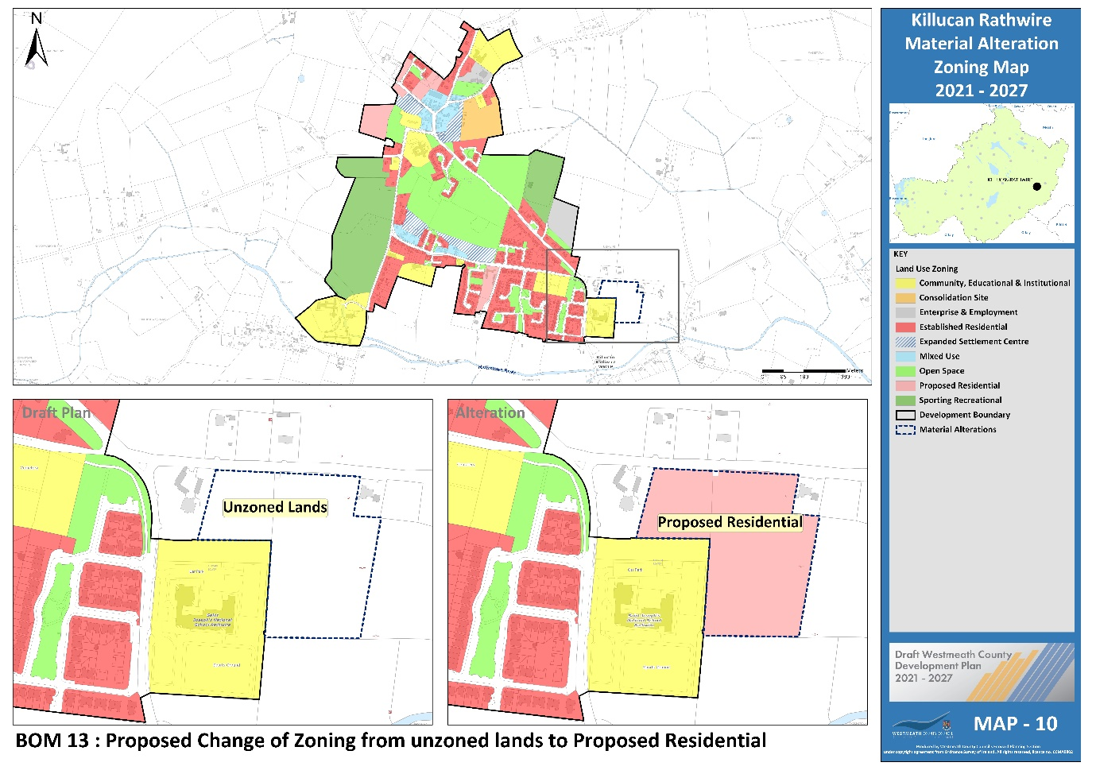

Proposed Amendment BOM 14

Title | Map No.
Killucan Rathwire Zoning | 10

Change zoning from “Open Space” to “Proposed residential”

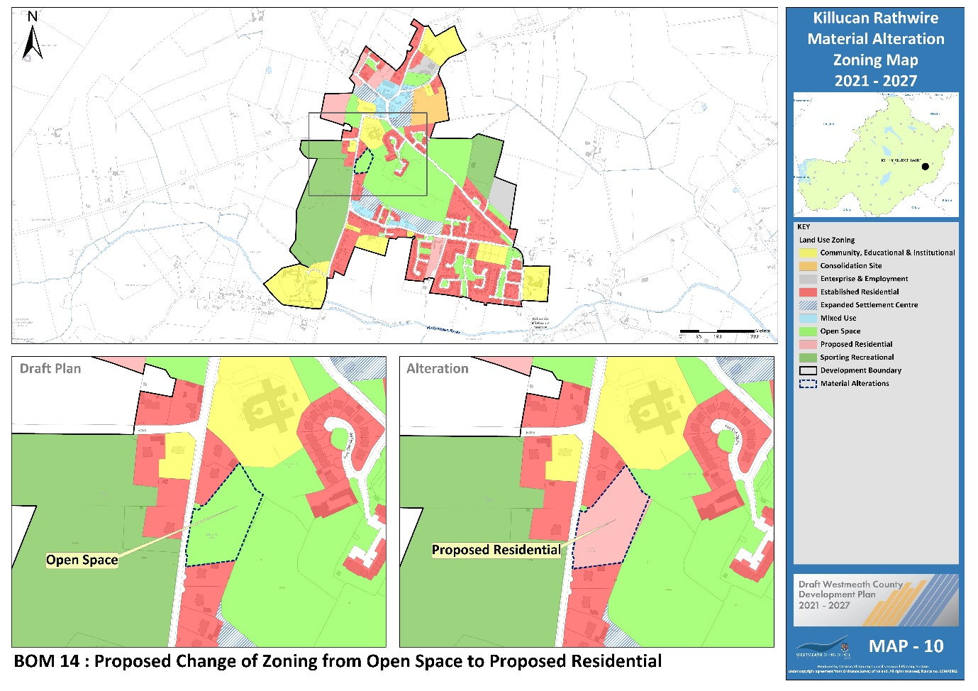

Proposed Amendment BOM 15

Title | Map No.
Killucan Rathwire Objective | 11

Insert new CPO for Killucan-Rathwire under section 8.4.1.6 of the plan as follows:
Development proposals on identified lands shall be accompanied by a site-specific Flood Risk Assessment (FRA) carried out in accordance with the methodology set out in ‘The Planning System and Flood Risk Management – Guidelines for Planning Authorities, 2009’ (See Map 11 MBLO KR 1).

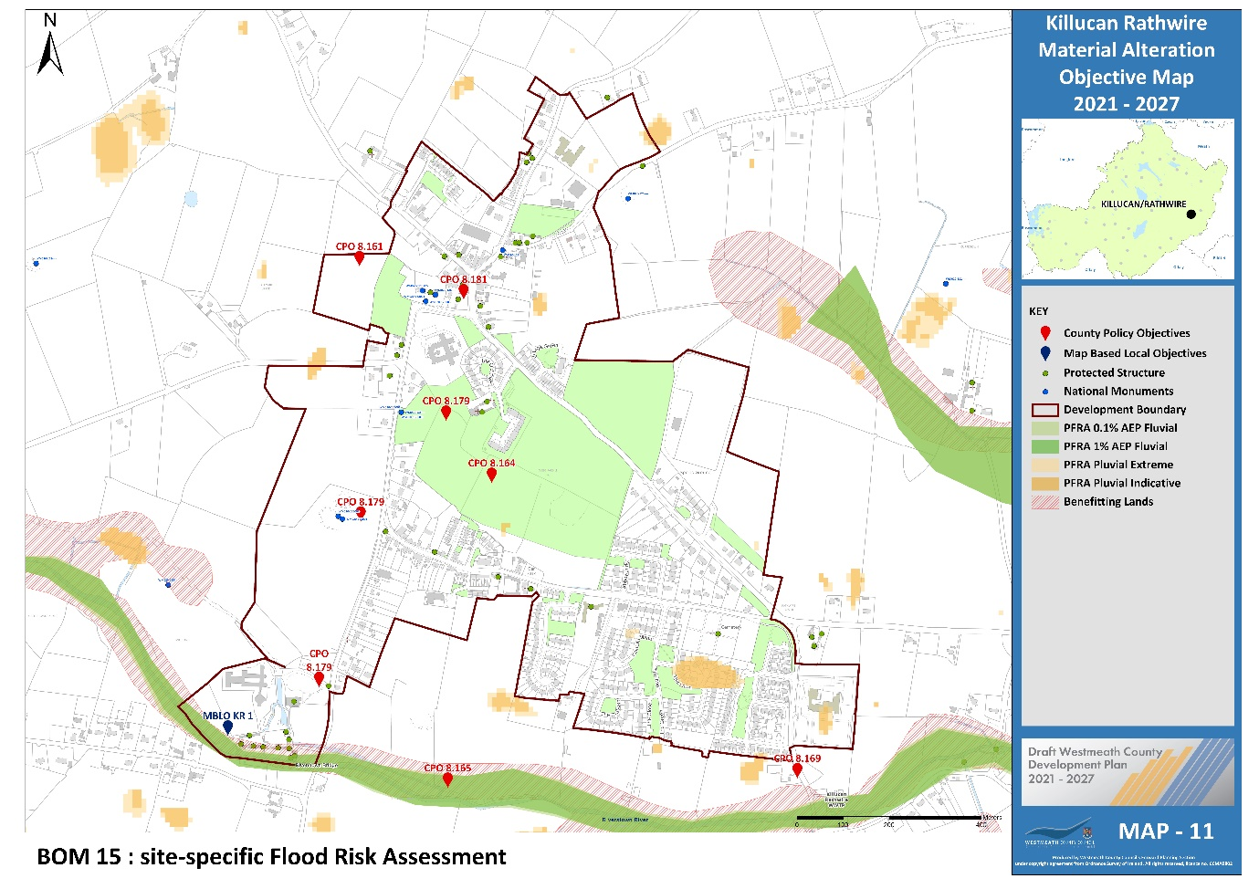

Proposed Amendment BOM 16

Title | Map No.
Rochfortbridge Zoning | 12

Change zoning from unzoned to “Proposed residential”

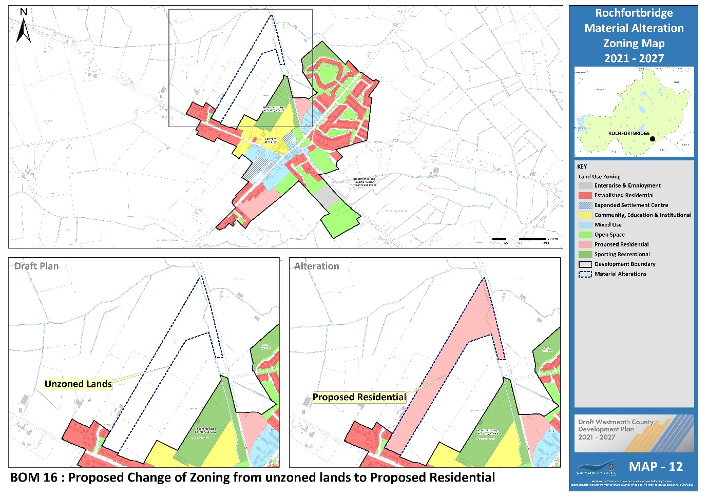

Proposed Amendment BOM 17

Title | Map No.
Rochfortbridge Zoning | 12

Change “Proposed Residential” and “Enterprise and Employment” zoning to “Open Space”

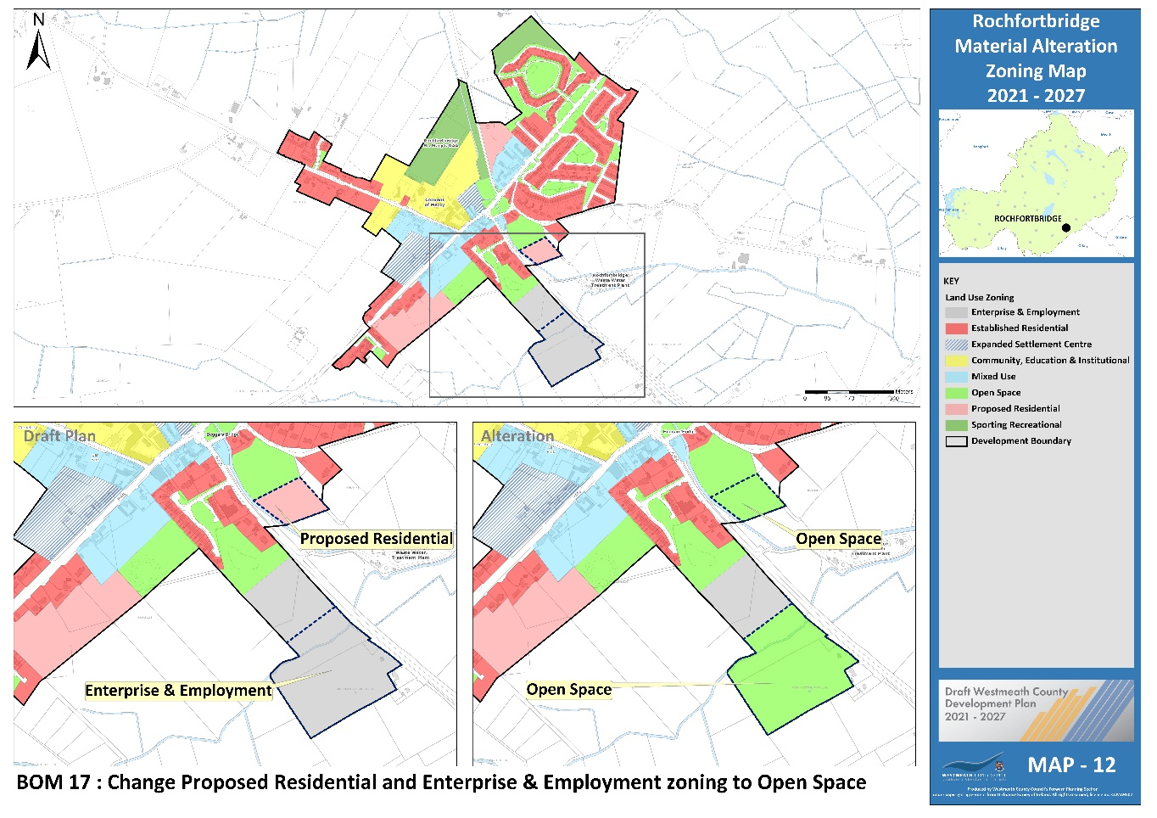

Proposed Amendment BOM 18

Title | Map No.
Clonmellon Objective | 15

Insert new CPO for Clonmellon under section 8.5.1.7 of the plan as follows:
Development proposals on identified lands shall be accompanied by a site-specific Flood Risk Assessment (FRA) carried out in accordance with the methodology set out in ‘The Planning System and Flood Risk Management – Guidelines for Planning Authorities, 2009’ (See Map 15 MBLO CM 1).

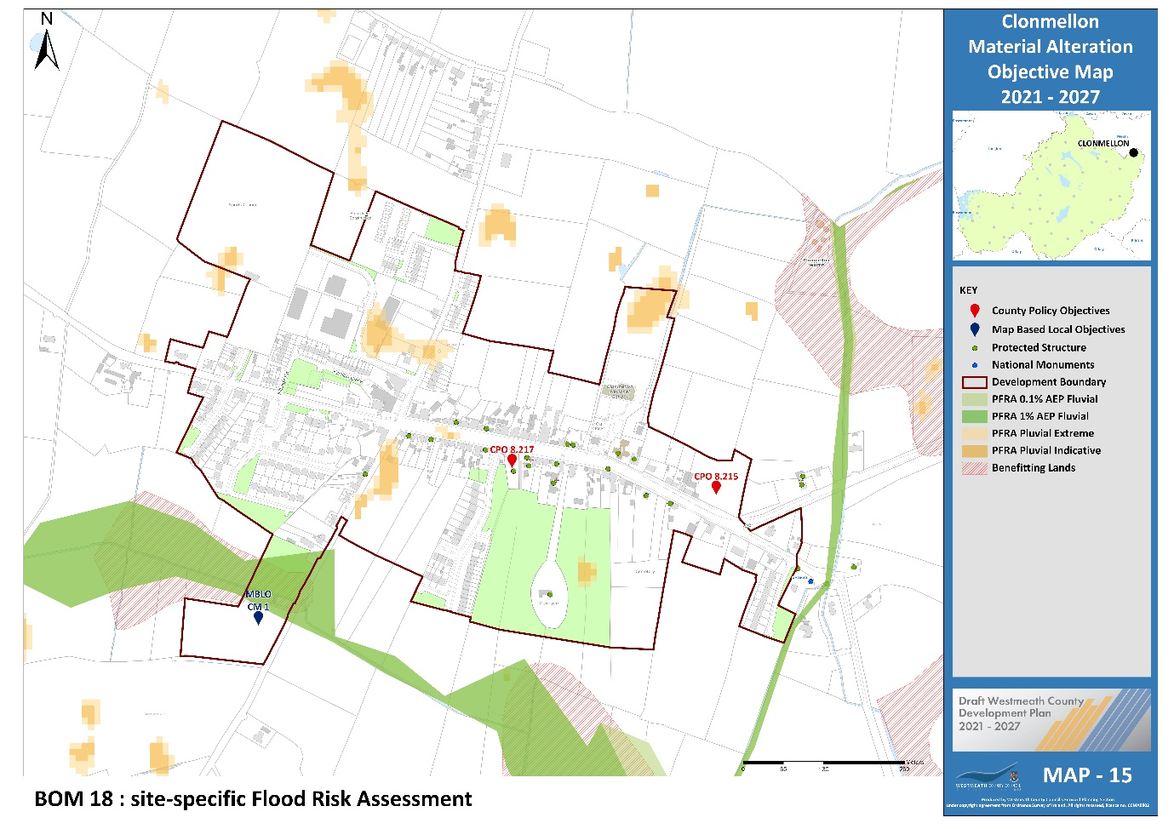

Proposed Amendment BOM 19

Title | Map No.
Delvin Zoning | 16

Change zoning from unzoned to “Proposed residential” and from “Proposed Residential to unzoned.

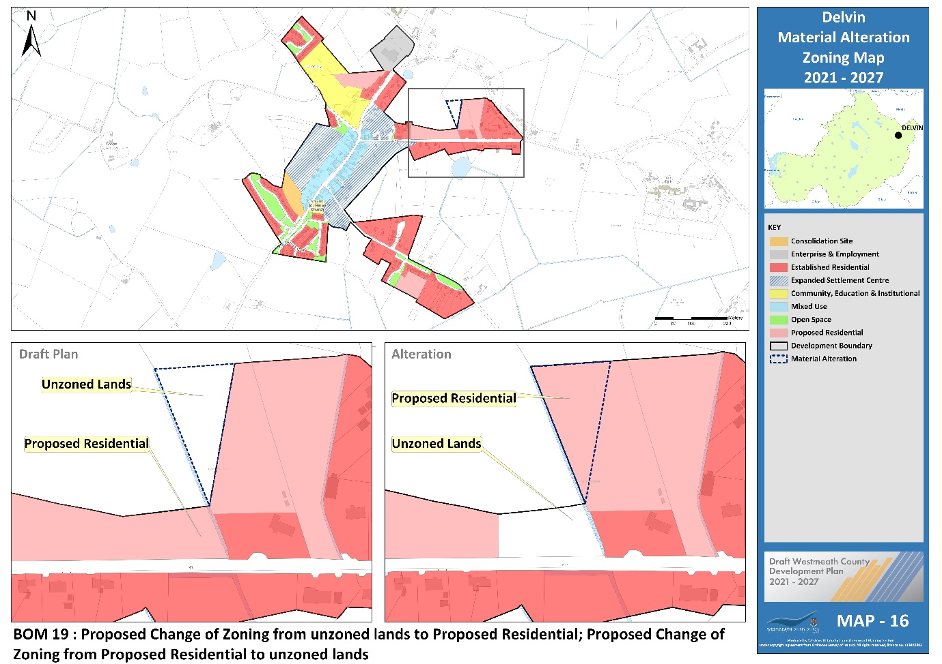

Proposed Amendment BOM 20

Title | Map No.
Delvin Objective | 17

Insert new CPO for Delvin under section 8.5.2.5 of the plan as follows:
Development proposals on identified lands shall be accompanied by a site-specific Flood Risk Assessment (FRA) carried out in accordance with the methodology set out in ‘The Planning System and Flood Risk Management – Guidelines for Planning Authorities, 2009’ (See Map 17 MBLO DV 1).

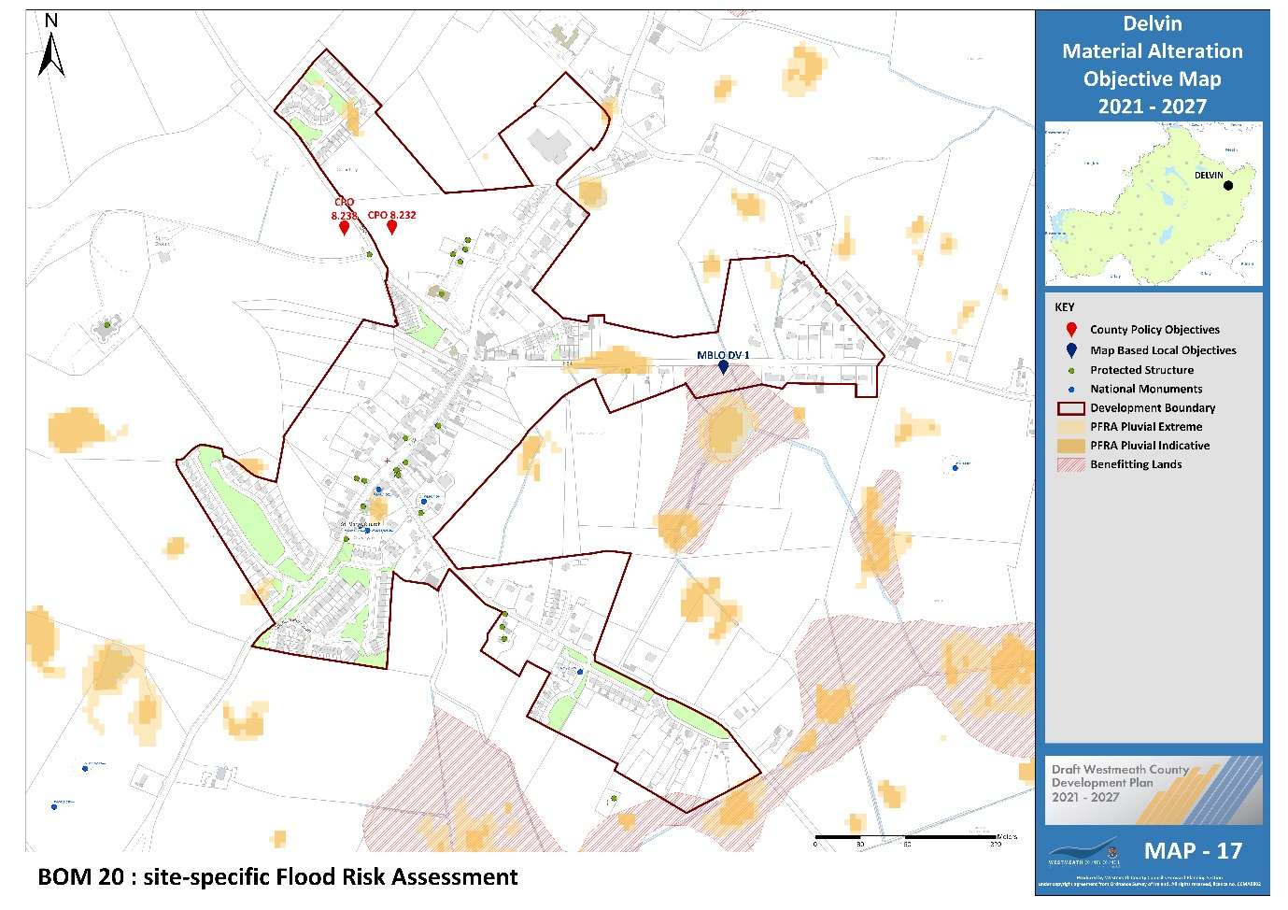

Proposed Amendment BOM 21

Title | Map No.
Tyrrellspass Zoning | 19

Insert new CPO after CPO 8.249 of the plan as follows:
Any proposal for development at these lands shall be accompanied by an Ecological Impact Assessment that considers ecological sensitivities, including those relating to the nearby Cloncrow Bog NHA, and the proposed design of any development. The Ecological Impact Assessment shall demonstrate the compliance of the proposal with the provisions of the Plan relating to biodiversity and flora and fauna; and that the NHA will not be adversely affected by the proposed development (See Map 19 MBLO TP 1).
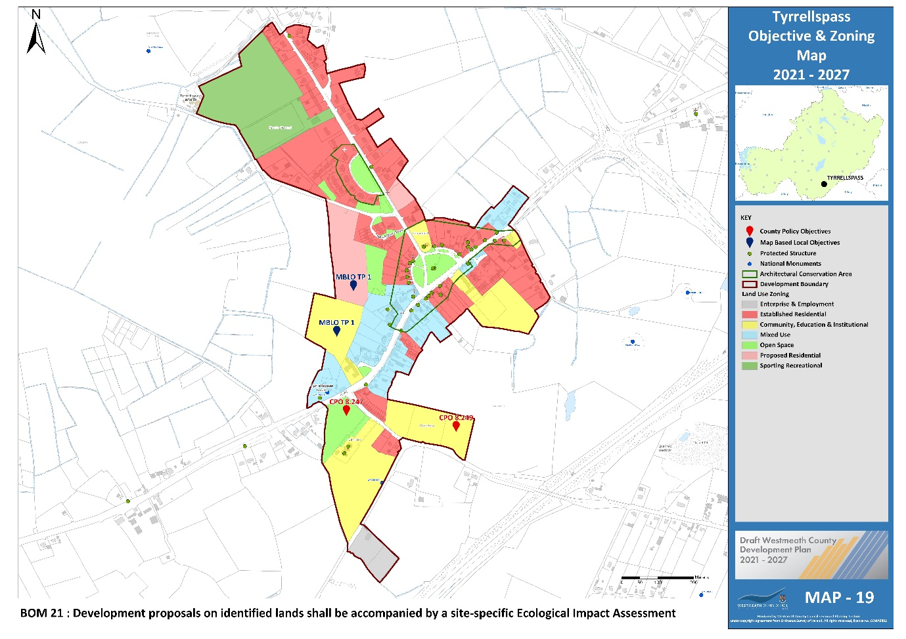

Proposed Amendment BOM 22

Title | Map No.
Ballinalack Objective | 20

Insert new policy objective for Ballinalack under section 8.6.1 of the plan as follows:
Development proposals on identified lands shall be accompanied by a site-specific Flood Risk Assessment (FRA) carried out in accordance with the methodology set out in ‘The Planning System and Flood Risk Management – Guidelines for Planning Authorities, 2009’ (See Map 20 MBLO BL 1).

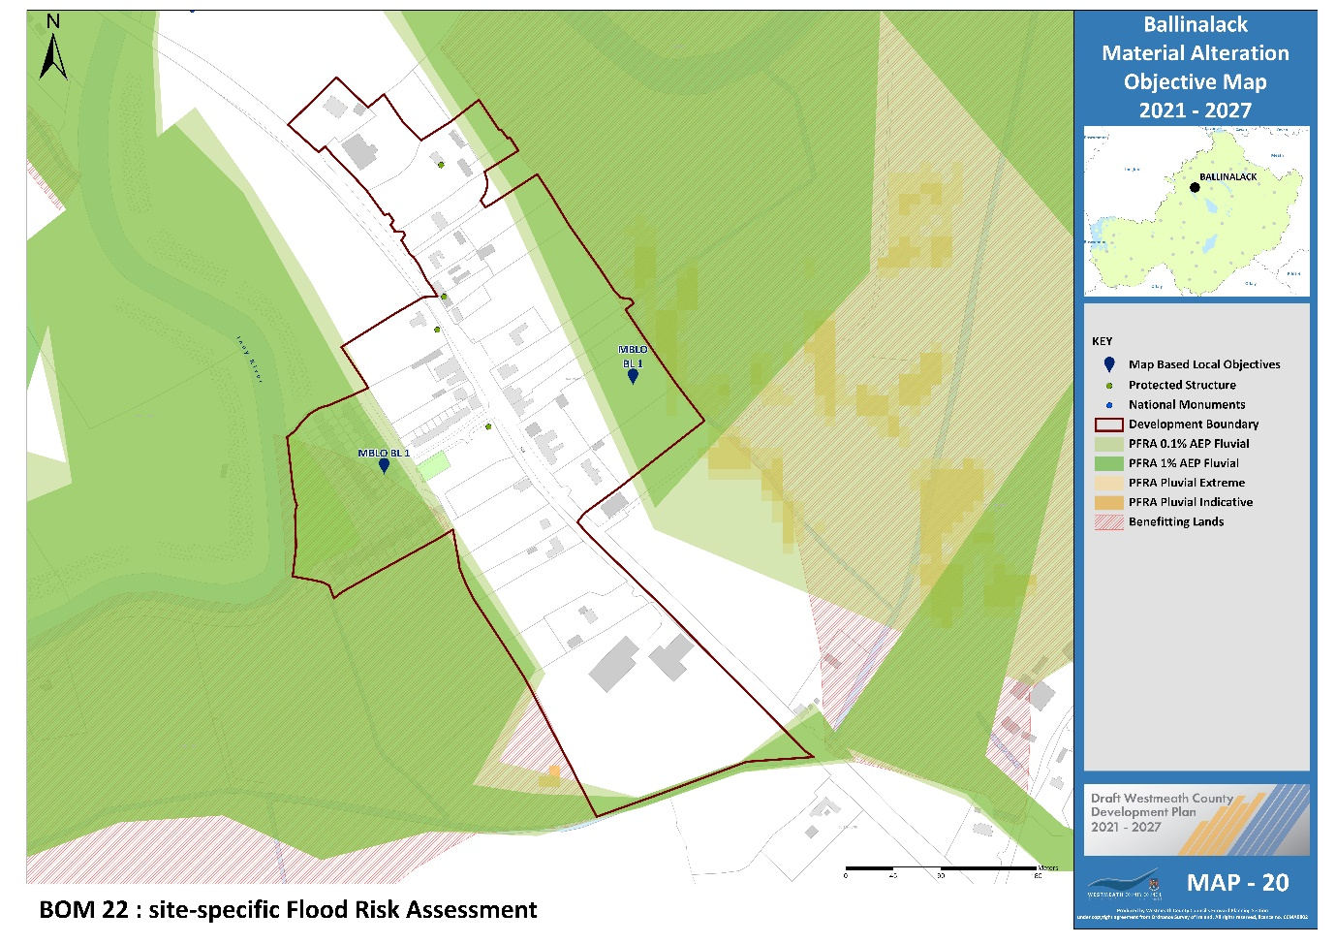

Proposed Amendment BOM 23

Title | Map No.
Ballymore Zoning | 21

Change zoning from unzoned to “Proposed residential”.

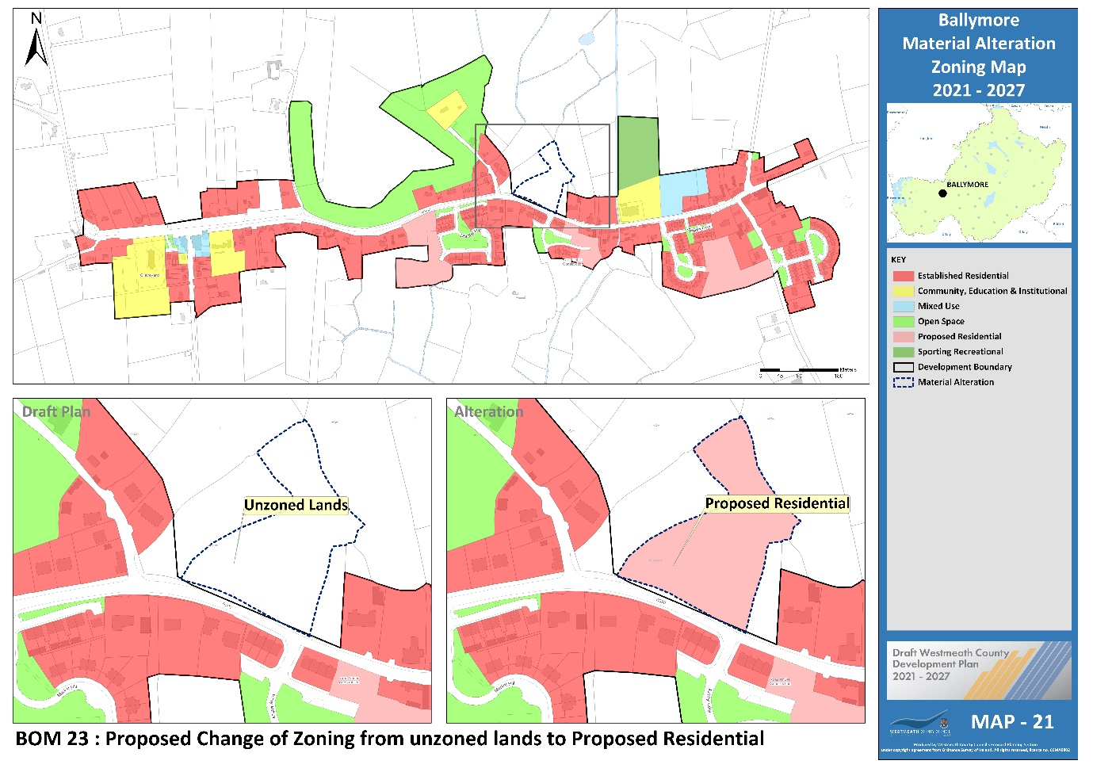

Proposed Amendment BOM 24

Title | Map No.
Ballymore Objective | 21

Insert new policy objective for Ballymore under section 8.6.2 of the plan as follows:
Development proposals on identified lands shall be accompanied by a site-specific Flood Risk Assessment (FRA) carried out in accordance with the methodology set out in ‘The Planning System and Flood Risk Management – Guidelines for Planning Authorities, 2009’ (See Map 21 MBLO BM 1).

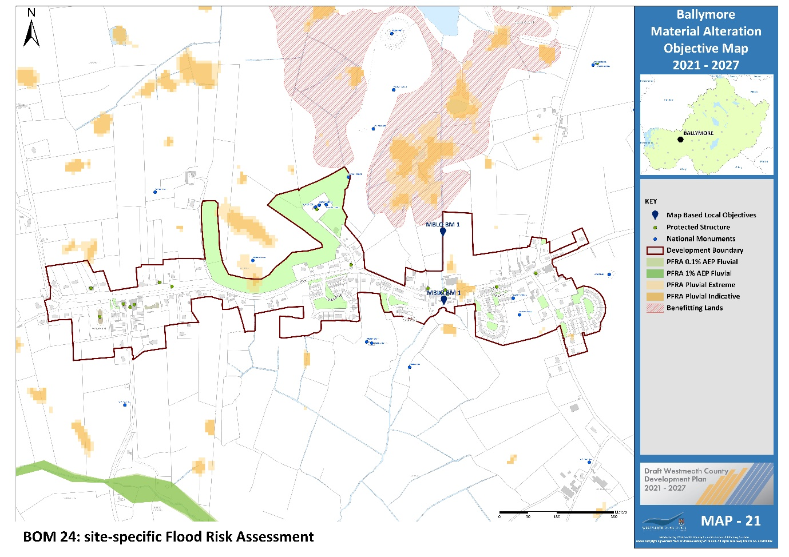

Proposed Amendment BOM 25

Title | Map No.
Castletown Geoghegan Zoning | 23

Change zoning from “Established Residential” to “Mixed Use”.

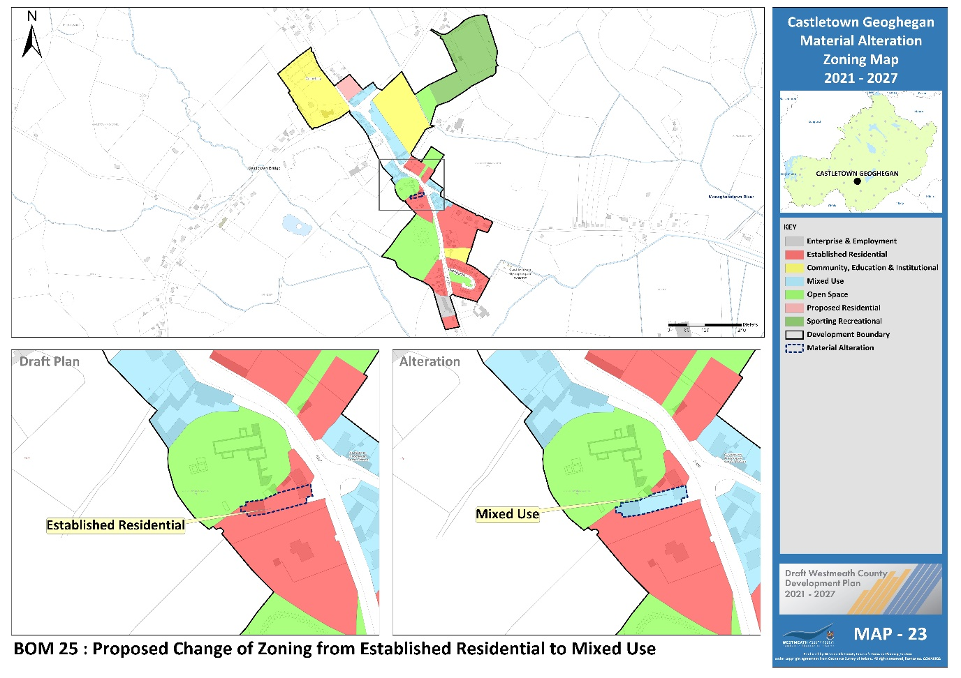

Proposed Amendment BOM 26

Title | Map No.
Castletown Geoghegan Zoning | 23

Change zoning from “Established Residential” to “Mixed Use”.

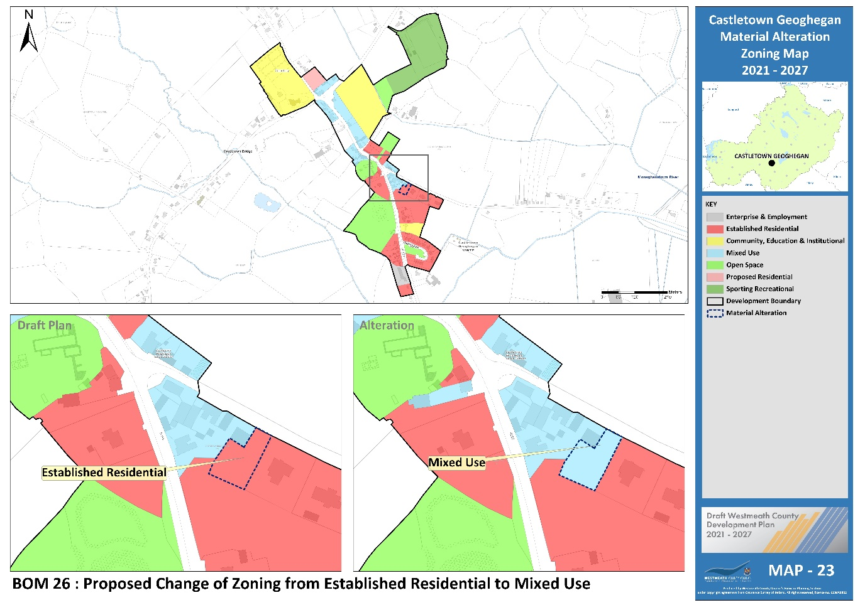

Proposed Amendment BOM 27

Title | Map No.
Castletown Geoghegan Objective | 23

Insert new policy objective for Castletown Geoghegan under section 8.6.4 of the plan as follows:
Development proposals on identified lands shall be accompanied by a site-specific Flood Risk Assessment (FRA) carried out in accordance with the methodology set out in ‘The Planning System and Flood Risk Management – Guidelines for Planning Authorities, 2009’ (See Map 23 MBLO CG 1).

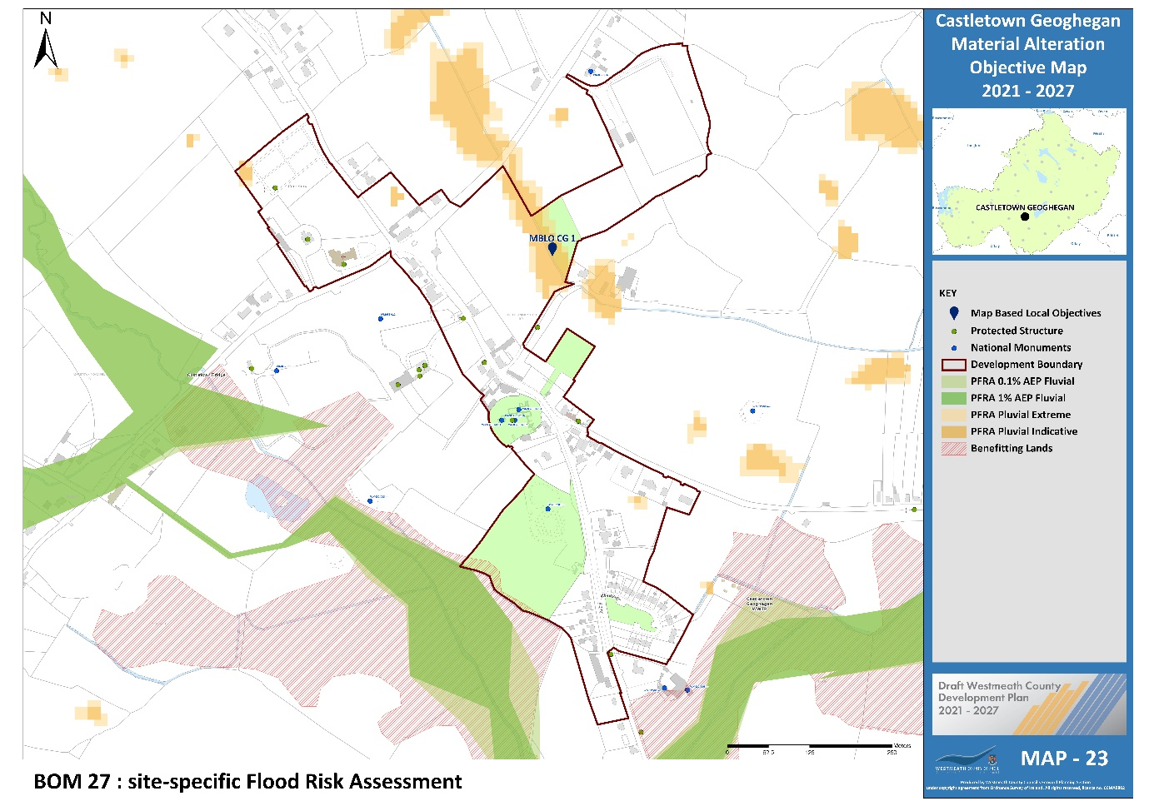

Proposed Amendment BOM 28

Title | Map No.
Collinstown Objective | 24

Insert new policy objective for Collinstown under section 8.6.5 of the plan as follows:
Development proposals on identified lands shall be accompanied by a site-specific Flood Risk Assessment (FRA) carried out in accordance with the methodology set out in ‘The Planning System and Flood Risk Management – Guidelines for Planning Authorities, 2009’ (See Map 24 MBLO CT 1).

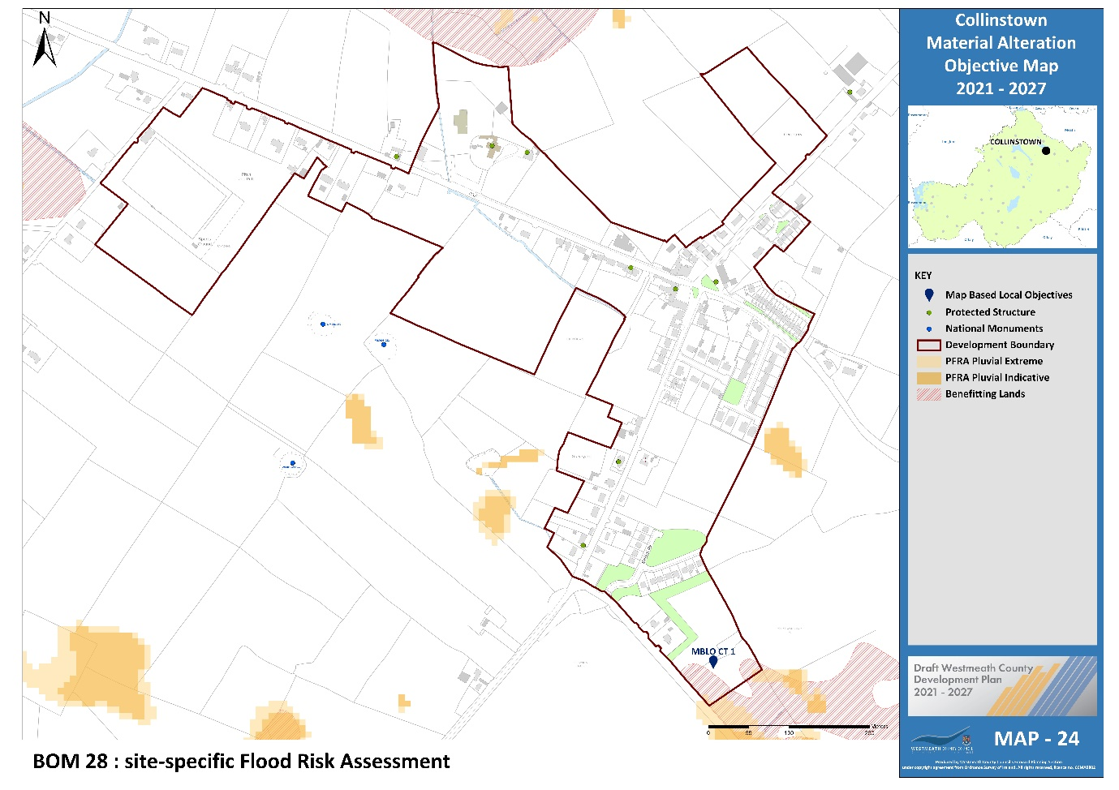

Proposed Amendment BOM 29

Title | Map No.
Glasson Zoning | 25

Change zoning from unzoned to “Proposed Residential”

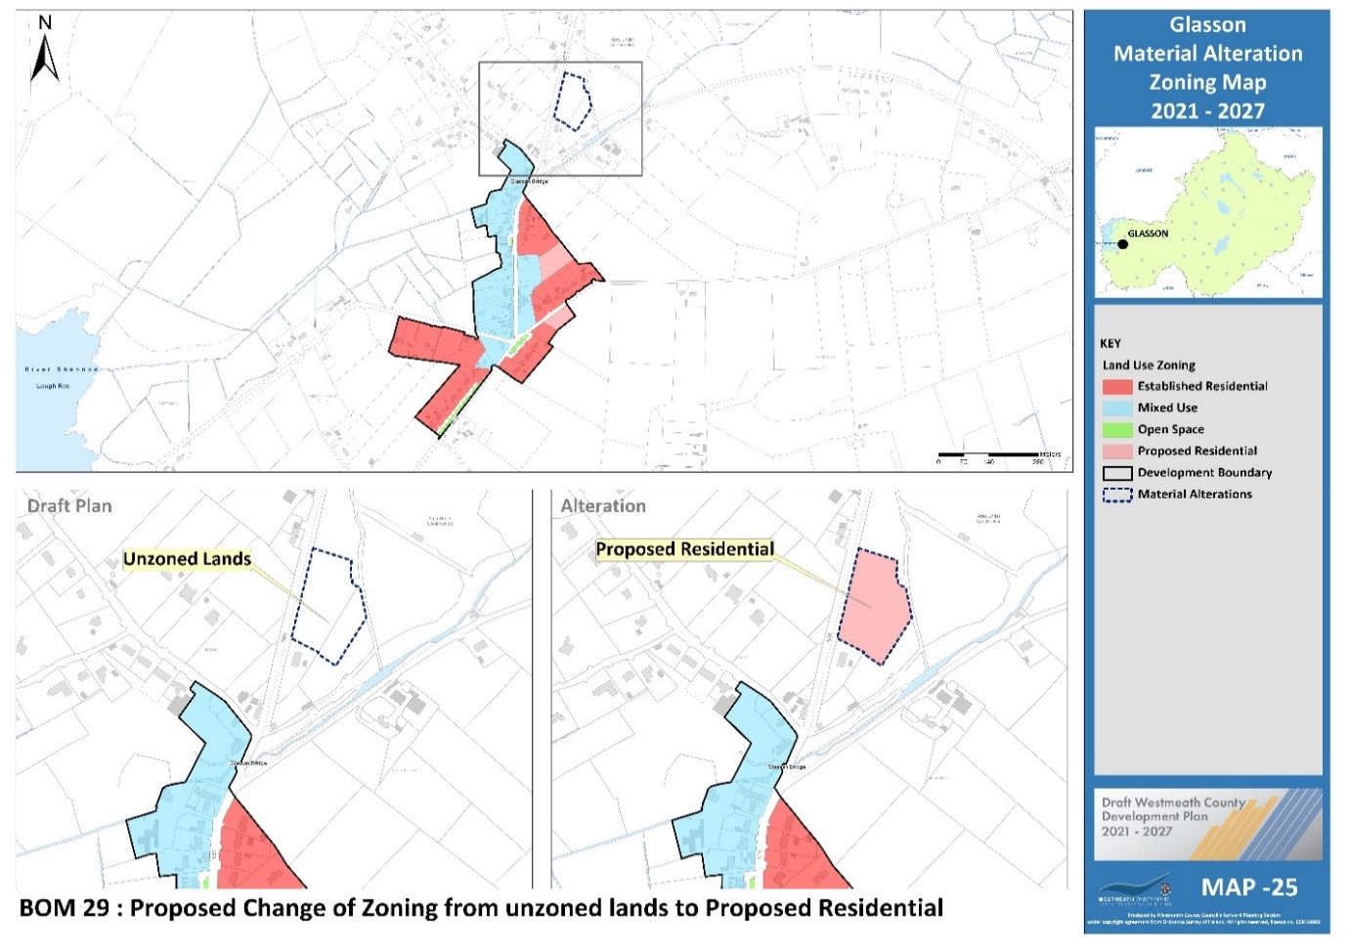

Proposed Amendment BOM 30

Title | Map No.
Glasson Zoning | 25

Change zoning from “Mixed Use” to “Open Space”.

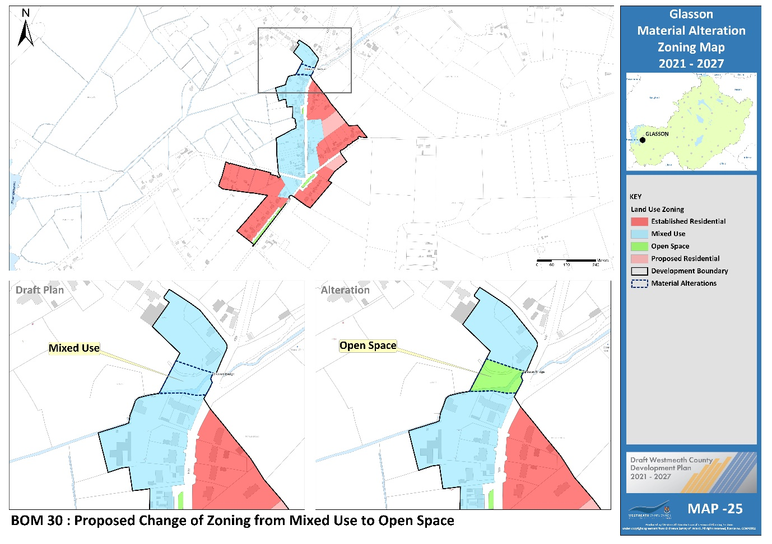

Proposed Amendment BOM 31

Title | Map No.
Milltownpass Zoning | 26

Change zoning from “Proposed Residential” to “Open Space”.

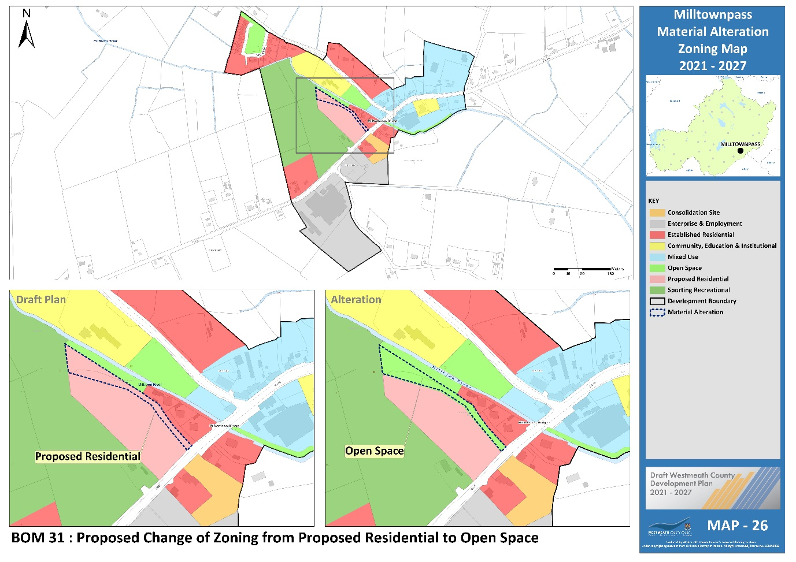

Proposed Amendment BOM 32

Title | Map No.
Multyfarnham Zoning | 27

Change zoning from “Open Space” to “Established Residential”

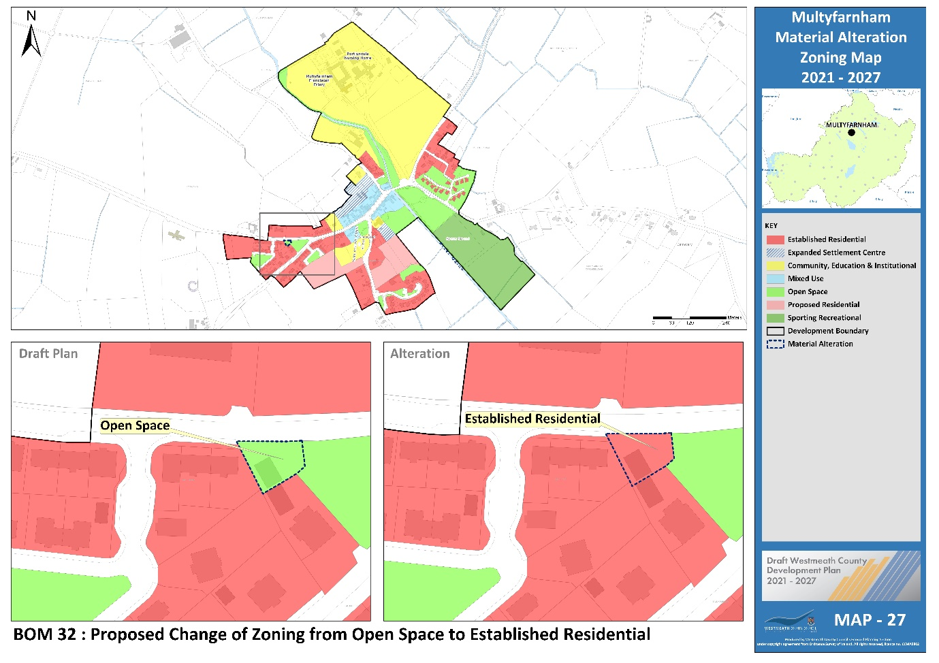

Proposed Amendment BOM 33

Title | Map No.
Loughnavalley Node | 34

Include Map boundary for clarification purposes.

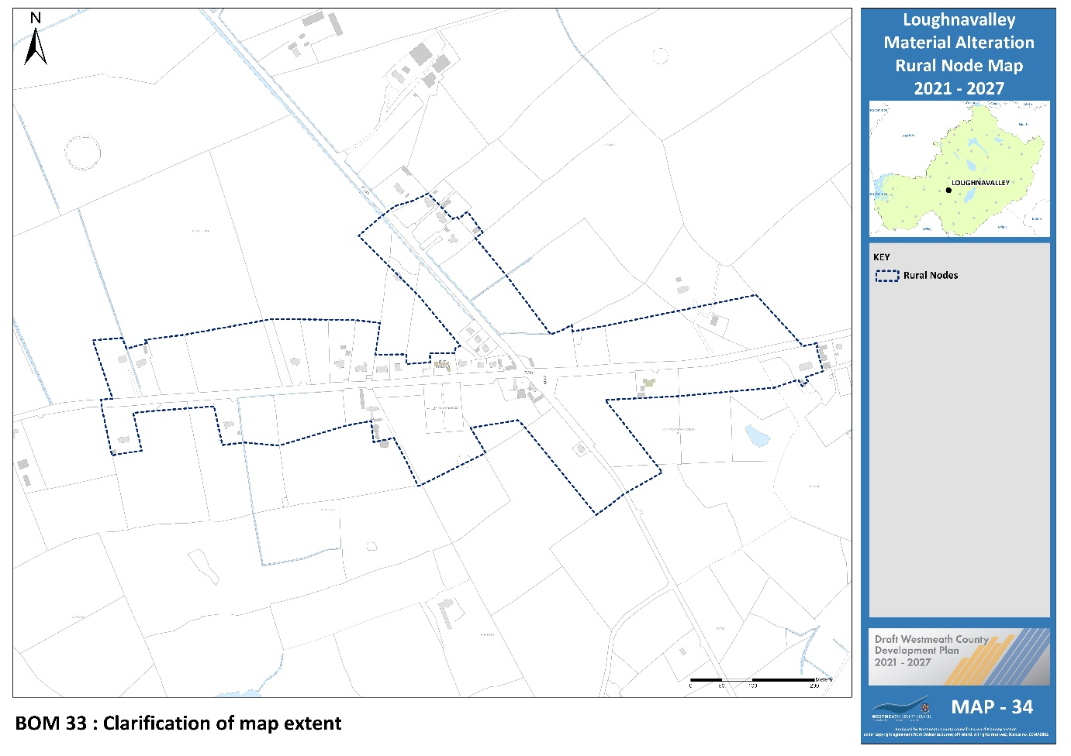

Proposed Amendment BOM 34

Title | Map No.
High Amenity Area | 42

Include previously omitted lands as part of Lough Lene High Amenity Area.

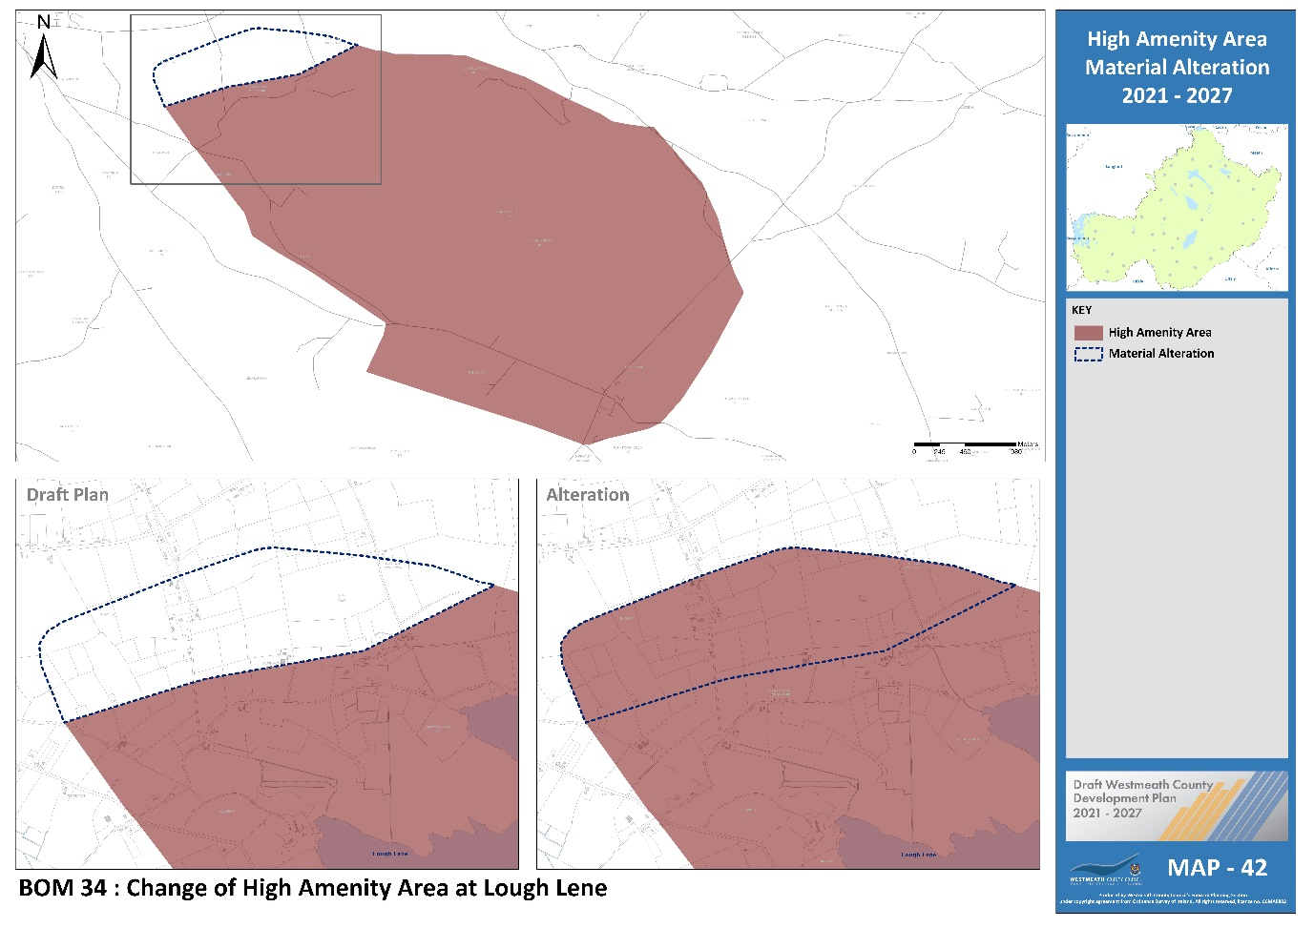

Proposed Amendment BOM 35

Title | Map No.
High Amenity Area | 42

Include previously omitted lands as part of Lough Derravaragh High Amenity Area.

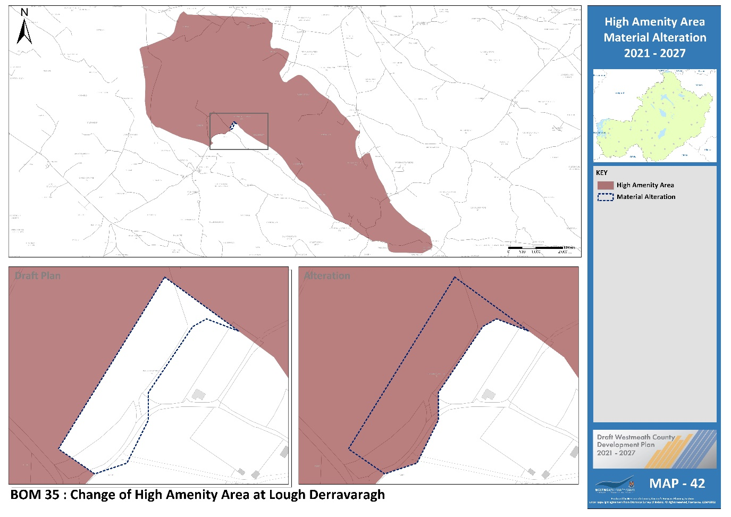

Proposed Amendment BOM 36

Title | Map No.
Wind Energy Capacity | 48

Designate Area 7 as Low wind energy capacity –

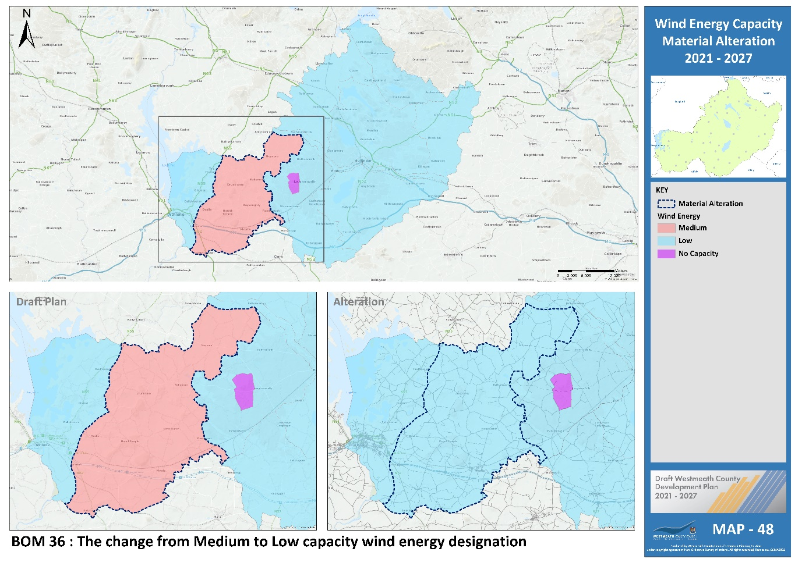
Area 7 identified in orange and classified as medium capacity.

